**Name:** Niyomwungeri Parmenide ISHIMWE

**Andrew-ID:** parmenin

**DATA, INFERENCE, AND APPLIED MACHINE LEARNING**

**18-785**

ASSIGNMENT 0

3 SEPTEMBER 2022

----------------------------------------------------------------------------------------------------------------

I, the undersigned, have read the entire contents of the syllabus for course 18-785 (Data

Inference and Applied Machine Learning) and agree with the terms and conditions of

participating in this course, including adherence to CMU's AIV policy.

Signature: **Niyomwungeri Parmenide ISHIMWE**

Andrew ID: **parmenin**

Full Name: **Niyomwungeri Parmenide ISHIMWE**

**The libraries used:**

* import numpy as np
* import pandas as pd
* import matplotlib.pyplot as plt

The first task of displaying the string “Hello Data Inference and Machine Learning” is done by using the print function from Python.

The three mathematical constants are described below in the following picture:

1. **Pi:** frequently denoted by π, it is a mathematical constant that is approximately equal to **3.141592653589793.** In python, **Pi** is available in math library and in NumPy library as well.
2. **e:** Euler's constant (e), is a mathematical constant that is approximately equal to **2.718281828459045** and it is frequently used as the base of natural logarithms or Neperian’s logarithms.In python, **e** is available in math library and in NumPy library as well.
3. **Phi:** Two numbers are said to be in the golden ratio if their ratio is the same as the ratio of their sum to the larger of the two quantities. **Phi** is approximately equal to **1.618033988749895.**

The formula for **phi** is **((a +b) / a) = a/b = phi** where **a>b>0.**

The last step was to sum up the three constants and then displaying them.

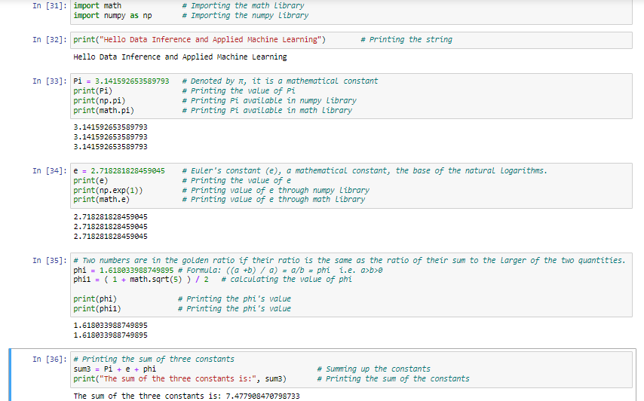

**Figure 1: Describing Pi, e, and Phi**